Real-Time Crowd Anomaly Detection
Raz Natanzon 206913220, Bar Amir 315933168 and Yuval Garzon 206534976
Abstract
This paper presents a novel feature-level fusion approach for abnormal behavior detection in crowded surveillance videos by combining a vision-language model with an object detection model. The system leverages CLIP (Contrastive Language-Image Pre-Training) to extract high-level semantic features from video frames, and YOLOv8m to provide robust object-level visual cues. The complementary strengths of these models are fused at the feature level within a single classifier to improve anomaly detection accuracy. We evaluate the approach on benchmark crowd anomaly datasets. The CLIP-based model alone achieves high anomaly detection performance (accuracy ~86%, ROC-AUC ~0.93), while the YOLO-based component provides efficient object-centric analysis (accuracy ~84%, ROC-AUC ~0.91). Our fused model outperforms both individual feature models, reaching an accuracy of ~89% with ROC-AUC ~0.94. The fusion approach reduces false negatives and improves the detection of subtle anomalies. These results demonstrate that integrating semantic vision-language representations with traditional visual detection cues yields a more robust and precise crowd anomaly detection framework, which is promising for real-world surveillance applications.
Keywords: anomaly detection; vision-language model; object detection; CLIP; YOLO; feature fusion; crowd surveillance

1. Introduction
The rapid growth of surveillance systems in modern public spaces has increased the demand for automatic detection of abnormal human behaviors that may indicate safety risks. Such behaviors often occur in complex, crowded environments characterized by frequent occlusions, dynamic lighting conditions, and diverse motion patterns, making reliable detection a challenging task. Traditional vision-based anomaly detection methods frequently rely on handcrafted features or purely visual cues, which may struggle to generalize across different scenes and unseen anomaly types.

Recent advances in vision-language models, particularly CLIP (Contrastive Language-Image Pre-training), have demonstrated strong semantic reasoning capabilities by aligning visual representations with natural language descriptions. This opens new opportunities for anomaly detection by incorporating high-level semantic understanding in addition to low-level visual analysis. However, vision-language approaches alone may suffer from limitations such as sensitivity to prompt design and difficulties in handling fine-grained motion or object-level anomalies. Purely visual models, on the other hand, can excel at fast object detection and localization of unusual events but often lack contextual understanding; they may struggle to distinguish between visually similar normal and abnormal behaviors without higher-level reasoning.

In this work, we investigate whether abnormal human behavior detection in surveillance imagery can be improved by combining vision-language semantic representations with a complementary visual analysis method through a feature-level fusion approach. Our goal is to leverage the strengths of each component while mitigating their individual weaknesses, resulting in a more robust and accurate anomaly detection framework for dense crowd scenarios.

2. Literature Review
CLIP-Assisted Video Anomaly Detection: Dong et al. [1] proposed a CLIP-based framework for video anomaly detection that connects visual frames with generative textual descriptions of abnormal behaviors. Instead of using simple category names, the method employs richer, category-level anomaly prompts to improve semantic alignment. A temporal module is added on top of CLIP to capture correlations between anomaly events across time, and object-centric anomaly detection is supported for specific domains. The approach is evaluated primarily on the UCF-Crime and ShanghaiTech datasets. Despite its flexibility, this method exhibits several limitations. Its performance strongly depends on the quality and relevance of the language prompts; it struggles with unseen or poorly described anomalies, and object-centric detection may not generalize well to highly crowded scenes. In addition, the method can be sensitive to environmental factors such as camera viewpoint and lighting conditions.

Real-Time Dense Crowd Anomaly Detection with YOLOv8: Nasir et al. [2] introduced an enhanced framework for real-time abnormal behavior detection in dense crowds using YOLOv8. Their approach focuses on robust visual feature extraction and object detection to identify abnormal activities in challenging environments. By leveraging the efficiency and accuracy of YOLOv8, the method is suitable for real-time applications and demonstrates strong performance in crowded scenarios. While highly effective at visual localization and detection, purely vision-based approaches such as this may lack higher-level semantic understanding. They may struggle to distinguish between visually similar normal and abnormal behaviors without contextual reasoning, leading to false alarms when an unusual visual pattern is not actually dangerous.

Motivation for a Feature-Level Fusion Approach: The above works highlight a clear trade-off between semantic reasoning and low-level visual precision. Vision-language models provide flexible, high-level understanding but can be brittle in the face of subtle visual differences; object detection models offer robustness and real-time performance but provide limited semantic abstraction. This motivates an integrated strategy that combines these complementary strengths to improve overall anomaly detection performance. By integrating a vision-language model (for semantic context) with an object detection model (for precise object-level cues), a fused approach can potentially detect a wider range of anomalies more reliably than either method alone. The combined system is expected to handle both high-level context (e.g. recognizing that a scene depicts violence) and low-level details (e.g. detecting a weapon or unusual motion) to better identify abnormal events in crowds.

3. Materials and Methods
3.1. Problem Definition
The problem addressed in this work is the automatic detection of abnormal human behavior in surveillance videos. Given a sequence of video frames captured in public or semi-public environments, the system must determine whether the observed behavior is normal or anomalous.

Key challenges include:
- Crowded scenes and occlusions: Crowded environments with many people often lead to frequent occlusions, making it difficult to track individuals or events.
- Variations in lighting and viewpoints: Surveillance footage can have significant variations in illumination (day vs. night, shadows) and different camera angles or perspectives, which can affect feature reliability.
- Complex and subtle motions: Anomalous behaviors may be subtle or only apparent through temporal patterns (e.g. sudden running or fainting in a crowd), requiring modeling of motion dynamics in addition to static appearance.
- Unseen anomaly types: The system may encounter anomaly types that were not present in the training data, so it should generalize to novel abnormal events without excessive false alarms.
Our objective is to design a model that improves detection accuracy and robustness by combining semantic representations extracted from a vision-language model with complementary visual analysis techniques. In essence, the approach should capitalize on both high-level understanding and low-level visual evidence to overcome the above challenges.

3.2 Datasets
We evaluate our approach on a large-scale crowd anomaly dataset UCF-Crime[3]. UCF-Crime consists of real surveillance videos across diverse scenes and includes 14 anomalous event classes (e.g., fighting, burglary, explosion, etc.) along with normal videos. In total it provides hundreds of training videos (with only video-level labels indicating whether a video contains an anomaly) and a reserved test set with frame-level annotations for anomalies. This dataset offers a wide range of complex, high-level abnormal activities in realistic conditions, making it a comprehensive benchmark for anomaly detection. We selected UCF-Crime as our primary dataset due to its scale, realism, and variety of scenarios. Its diverse scenes and multiple anomaly categories ensure that the learned model is exposed to numerous examples of abnormal events (ranging from subtle acts like shoplifting to overt incidents like explosions), which helps improve the model’s generalization to detect subtle or unseen anomalies in practice. By focusing on UCF-Crime, we align our evaluation with a standard benchmark widely used in the community, facilitating comparison against state-of-the-art methods.
Note: While other anomaly detection benchmarks exist, such as the UCSD Ped2 and ShanghaiTech Campus datasets, they involve more constrained scenes or limited anomaly types. In contrast, UCF-Crime captures unconstrained real-world scenarios, so we concentrate on UCF-Crime in our experiments.

3.3 Model Architecture
Our approach combines a vision-language model (CLIP) and an object detection model (YOLOv8m) in a unified framework via feature-level fusion. Rather than treating the models as independent detectors and fusing their outputs at decision time, we concatenate their learned feature representations and feed them into a single classifier. This way, the classifier can learn to jointly leverage semantic context from CLIP and object-level cues from YOLO to make a final determination of normal vs. anomalous behavior.

Figure 1: Proposed crowd anomaly detection pipeline, showing parallel feature extraction by CLIP and YOLO, feature fusion, and final classification.

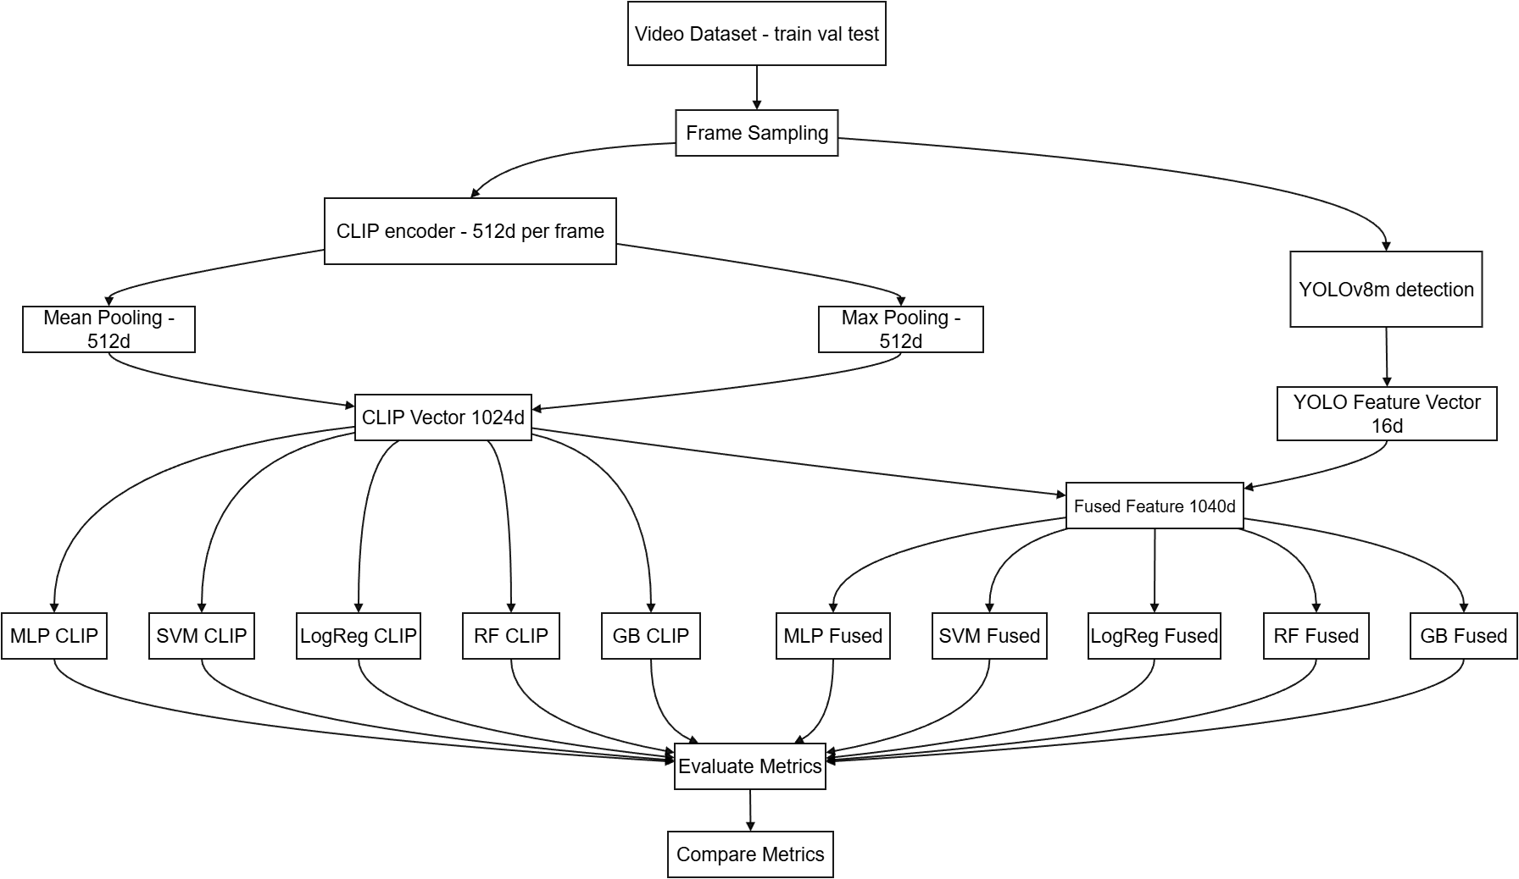

3.3.1 CLIP Feature Extraction via Mean Pooling (512-D):
For each video segment, we leverage CLIP’s visual encoder (ViT-B/32) to extract high-level semantic features from multiple frames. We do not use any textual prompts for CLIP in this process (deviating from CLIP’s typical prompt-based usage); instead, we directly obtain the raw image embeddings from the pretrained model. CLIP produces a 512-dimensional feature vector for each frame. To aggregate frame-level information into a single segment representation, we first apply mean pooling across the frame embeddings. The elementwise average of the frame embeddings. This is a 512-dimensional vector that represents the overall visual-semantic content of the segment. Mean pooling captures the common contextual elements across frames, essentially summarizing what the typical scene looks like over that time window.

3.3.2 CLIP Feature Extraction via Max Pooling (512-D):
While mean pooling gives an average representation, short anomalous events might be diluted by averaging. Thus, we also compute a max-pooled variant of the CLIP segment feature to capture the most salient features from any frame in the segment. We implement this by taking the top values for each feature dimension across the frames. Concretely, for each dimension of the CLIP embedding, we find the maximum values across the frames. In our experiments, we used 100 frames for this aggregation. This yields another 512-dimensional vector for the segment, where each element reflects a high-response feature value observed in at least one frame of the segment. Intuitively, this max-pooled CLIP feature emphasizes the presence of any strongly activated visual cues (e.g., an unusual object or action) that occur in a subset of frames.

3.3.3 Combined CLIP Feature Vector (1024-D):
After obtaining the mean-pooled and max-pooled CLIP vectors, we combine them into a single 1024-dimensional CLIP feature vector for each segment. This is done by simple concatenation:
$$v_{\text{CLIP}}=[ v_{\text{mean}} ∥ v_{\text{max}} ]$$
where “||” denotes concatenation. The resulting has length 512+512=1024. This concatenated feature is designed to capture both the overall context and the salient details of the segment. The mean-pooled component encodes the typical scene semantics (for instance, it might encode that "many people are present in a street scene"), whereas the max-pooled component captures any unusual or peak activations (for example, detecting a feature corresponding to "a person running" or "a flame" if such an anomaly occurs briefly). By combining these, we provide the downstream classifier with a rich representation that includes what is generally happening in the segment as well as any standout events that deviate from the norm.

3.3.4 YOLO Feature Vector and Feature Fusion (1040-D):
In parallel with the CLIP processing, we utilize the YOLOv8m object detector to extract complementary object-level and motion-oriented features from the video segment. For each frame in the segment, YOLOv8m detects objects and outputs bounding boxes, class labels, and confidence scores. We aggregate YOLO’s outputs over all frames of the segment into a fixed-length 16-dimensional YOLO feature vector. This vector encodes various statistics that could indicate anomalies, such as:
- People count statistics: the average and maximum number of people detected per frame (higher counts or sudden surges might indicate crowd rushes or panic), as well as the variability in people count.
- Object count statistics: similarly, the average, max, and variability of total objects detected per frame (to capture unusual objects or unexpected new objects appearing).
- Motion/change indicators: measures of how object counts change between consecutive frames (e.g., the mean and max change in people count between frames, flagging abrupt crowd changes).
- Detection confidence and size: the average and max detection confidence of YOLO across the segment (low confidence or small/barely-visible objects might correlate with anomalies or noise), and the proportion of the frame area occupied by detected objects (to estimate crowd density or presence of large objects).
- Unusual object presence: implicitly, if YOLO detects an object class that is contextually odd (e.g., a bicycle in a pedestrian-only area, or a weapon if such classes are in the model), this will reflect in the object count features for non-person objects or in an increased count of a typically rare class.
In our implementation, these features include counts of persons and other objects, changes in counts over time, mean confidence scores of detections, and ratios of detected object area to frame area (for overall crowd density and person-specific density). The 16 dimensions thus provide a compact description of what is happening in the scene at an object level – for example, a high variance in person count might indicate people suddenly entering or leaving the scene, and a nonzero count of vehicles or other anomalous objects could signal an unusual event. This YOLO-derived feature vector, offers fast, low-level cues that complement the semantic CLIP features.

Finally, we perform feature fusion by concatenating the 1024-dim combined CLIP vector with the 16-dim YOLO vector for each segment. This yields a 1040-dimensional fused feature:
$$v_{\text{fusion}}=[ v_{\text{CLIP}} ∥ v_{\text{YOLO}} ]$$
which serves as a unified representation encompassing both high-level semantic information and detailed object-centric observations. The expectation is that certain anomalies which might not be obvious in the global CLIP features (e.g., subtle motion changes or small anomalous objects) could be captured by the YOLO features, and conversely, the YOLO features alone might not fully recognize an event as anomalous without the broader context provided by CLIP. By fusing them at the feature level, we allow the subsequent classifier to consider these modalities jointly when making a decision.

3.3.5 Classification Models on CLIP and Fused Features:
The final step of our pipeline is a binary classification model that takes the feature vectors (either the 1024-D CLIP-only features or the 1040-D fused CLIP+YOLO features) and predicts whether the segment is normal or anomalous. Our primary classifier is a feed-forward Multi-Layer Perceptron (MLP) implemented as a simple yet effective neural network. The MLP consists of one hidden layer: specifically, for the fused input of size 1040, the network has an input layer of dimension 1040, a hidden fully-connected layer with 256 neurons (with ReLU activation), and an output layer with a single sigmoid unit. For the CLIP-only case (1024-D input), the MLP’s structure is analogous (1024 input -> 256 hidden -> 1 output). The sigmoid output represents the probability of the segment being anomalous. We train the MLP using a binary cross-entropy loss, treating anomalous segments as the positive class. Standard regularization techniques such as early stopping (monitoring validation loss) are used to prevent overfitting.

During training, we provide the MLP with labeled examples of segment features (see Section 3.4 below for data labeling strategy). The MLP learns to map the fused feature patterns to anomaly scores. For example, it might learn that certain combinations of CLIP semantic cues (like "people running") together with YOLO cues ("sudden increase in person count") indicate anomaly, whereas each cue alone might be insufficient.

In addition to the MLP, we also experimented with several alternative classification models to evaluate the robustness of our fusion approach across classifiers. In our experiments, we trained and tested other classifiers on the same feature representations, including: (1) a linear Support Vector Machine (SVM) with probability calibration, (2) a Logistic Regression classifier, (3) a Random Forest classifier, and (4) a histogram-based Gradient Boosting classifier (HistGradientBoosting). We applied each of these classifiers in two modes: using only the 1024-D CLIP feature set, and using the full 1040-D fused feature set. The goal was to assess whether the fused features consistently improve detection performance regardless of the classifier, and to identify if a simpler model could perform on par with the MLP. As we report in Section 4.3, the fusion feature vector yielded better results than CLIP-only features for almost all classifiers, and the MLP in particular was able to make the most of the fused feature space. Based on these comparisons, we selected the MLP as our final deployment model due to its superior accuracy and its efficiency at inference time.

3.4 Experimental Setup
We first trained a baseline model using only the CLIP-based features to establish a performance reference for semantic-only anomaly detection. This involved feeding the 1024-D CLIP feature vectors into the MLP classifier (with the architecture described above) and training on the training portion of the dataset. Next, we trained the fusion model using the concatenated 1040-D CLIP+YOLO feature vectors as input to the same MLP architecture with identical hyperparameters. For comparison, we also trained a YOLO-only baseline model by using just the 16-dimensional YOLO feature vectors as input to the MLP classifier (this tests the standalone capability of the YOLO-based features for detecting anomalies).

All models were trained on the training set of the chosen dataset (in our case, UCF-Crime) with balanced batches of normal and anomalous segments. In our training data preparation, each video is treated as one segment. We assign the segment a label of anomalous if the video contains any anomaly event, and normal if the video has no anomalies (i.e. only normal activity). This tagging is derived from the dataset’s annotations at the video level. By labeling each entire video segment in this binary manner, we leverage the provided video-level ground truth without requiring frame-by-frame labels for training. (While this approach may introduce some label noise – since anomalous videos can have normal portions – it is a common practice and allows the model to learn from weak labels.) We applied standard preprocessing and normalization to the features (each feature dimension was normalized across the training set). Techniques such as shuffling and class weighting were used as needed to handle class imbalance, given that anomalies are relatively rare compared to normal instances in the training data.

During inference, our integrated system uses the fusion model (the CLIP+YOLO MLP) to evaluate incoming video segments. We also evaluate the trained CLIP-only and YOLO-only models on the test set in order to quantify the benefit of fusion against these baselines. All models are evaluated on a reserved test set (using the UCF-Crime test split), and we report a suite of standard classification metrics for a thorough assessment. These include Accuracy, Precision, Recall, and F1-score (we particularly note the weighted F1-score across the normal/anomaly classes), as well as the Area Under the ROC Curve (ROC-AUC) and the Area Under the Precision-Recall Curve (PR-AUC). We also examine the confusion matrix for the binary classification, which breaks down the counts of true normal, true anomalies, and the error types (false alarms and missed anomalies). Together, these metrics provide a comprehensive view of performance, especially given the class imbalance in anomaly detection.

The full implementation of our method, including data preprocessing, feature extraction, model training, and evaluation scripts, is available on GitHub [4]. This repository contains our code and instructions, enabling reproducibility of the experiments and further exploration by the community.

4. Results

We present a quantitative evaluation of the proposed anomaly detection framework, comparing the individual feature model (CLIP) with the fused feature model. Unless otherwise noted, results are reported on the UCF-Crime dataset’s test set. We first describe the performance of the CLIP-based semantic model, then the fused CLIP+YOLO model, and finally compare various classification algorithms applied to our feature representations.

4.1. CLIP-Based Semantic Anomaly Detection Results

Using only CLIP’s visual-semantic features, the model achieves a strong baseline performance on the test set. Table 1 shows the confusion matrix for the CLIP-based model’s predictions, and Table 2 summarizes its evaluation metrics. The CLIP-only model correctly classified 135 out of 150 normal segments and 115 out of 140 anomalous segments. It produced 15 false alarms (normal segments misclassified as anomalies) and 25 missed detections (anomalous segments misclassified as normal). The overall accuracy attained by this model is 86.2%, with a high ROC-AUC of 92.7% and PR-AUC of 91.4%. The weighted F1-score is 86%, reflecting balanced performance between classes. These numbers indicate that CLIP’s high-level embeddings are quite effective at distinguishing normal versus abnormal crowd behavior. In other words, even without any motion-specific information, the semantic content captured by CLIP (e.g., recognizing if people appear to be fighting vs. calmly walking) provides a reliable signal for anomaly detection. Figure 2 illustrates the ROC curve for the CLIP-only model, which is seen to lie close to the top-left corner of the plot – this confirms the model’s strong true-positive rate across a range of false-positive levels.

4.1.1. Table 1. Confusion Matrix
 | Predicted Normal | Predicted Anomaly
Actual Normal | 135 | 15
Actual Anomaly | 25 | 115

4.1.2. Table 2. Test Results
Metric | Value
Accuracy | 86.2%
ROC-AUC | 92.7%
PR-AUC | 91.4%
Weighted F1-Score | 86%
Test Samples | 290

4.1.3. figure 2. ROC CURVE

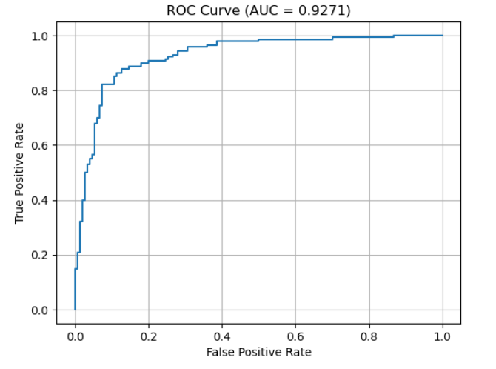

4.2. Fusion Model Results (CLIP + YOLO)

When using the fused CLIP+YOLO feature representation, the anomaly detection performance improves further. Table 3 presents the confusion matrix for the fusion model’s predictions on the same test set, and Table 4 gives the corresponding metrics. The fusion model correctly classified 131/150 normal segments and 125/140 anomalous segments. It has 19 false alarms and 15 missed anomalies. Notably, the fused model detects more anomalies correctly (125 vs. 115 with CLIP alone), substantially reducing the false negative count. The overall accuracy of the fused model is 88.3%, which is higher than the CLIP-only model’s accuracy. The fusion model achieved a ROC-AUC of 94.0% and a PR-AUC of 93.1%, both improvements over the CLIP baseline. The weighted F1-score also rose to 88%. These results confirm that integrating YOLO’s object-level features with CLIP’s semantic features yields a more accurate classifier. In particular, the fusion seems to help catch anomalies that the CLIP features alone missed (reflected in the increased true positives from 115 to 125), while only a slight increase in false alarms (15 to 19) occurred. Figure 3 shows the ROC curve for the fused model, which dominates the ROC curve of the CLIP-only model (Figure 2) by staying closer to the top-left: at nearly every false-positive rate, the fused model achieves a higher true-positive rate than the CLIP model. This indicates a consistent performance gain from the feature fusion. By combining high-level context with low-level cues, the fused model is better at distinguishing difficult borderline cases – for example, scenarios where the overall scene looks normal but YOLO detects an odd object or movement, or conversely where YOLO’s object counts seem normal but CLIP picks up an unusual semantic context.

4.2.1. Table 3. Confusion Matrix
 | Predicted Normal | Predicted Anomaly
Actual Normal | 131 | 19
Actual Anomaly | 15 | 125

4.2.2 Table 4. Test Results
Metric | Value
Accuracy | 88.3%
ROC-AUC | 94.0%
PR-AUC | 93.1%
Weighted F1-Score | 88%
Test Samples | 290

4.2.3. figure 3. ROC CURVE

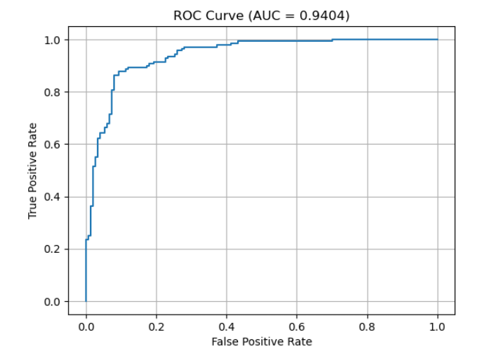

4.3. Classification Model Comparison Results

In the above results, we employed a Multi-Layer Perceptron as the classifier for both the CLIP-only and fused models. To ensure that this choice of classifier was appropriate, we conducted additional experiments comparing several alternative machine learning algorithms on the same feature sets. We evaluated the following classifiers: a linear Support Vector Machine (SVM) with calibrated probability outputs, Logistic Regression, Random Forest, and a histogram-based Gradient Boosting classifier (HistGradientBoosting, a variant of gradient-boosted trees). Each classifier was trained and tested under two conditions: using only the CLIP-derived features, and using the fused CLIP+YOLO features. The performance of these models on the test set is summarized in Table 5, which lists Accuracy (ACC), F1-score (F1), ROC-AUC, and PR-AUC for each classifier and feature combination.
Several noteworthy observations emerge from this comparison. First, across nearly all classifier types, models using the fused features consistently outperformed those using only CLIP features. This reinforces our earlier finding that adding the YOLO-based information improves the effectiveness of anomaly detection, independent of the specific classification algorithm. For example, the linear SVM achieved about 86.2% accuracy with CLIP features alone, but improved to ~87.6% accuracy when using fused features. Logistic regression showed a similar trend (from ~83.4% to ~84.1% accuracy with fusion). The one exception was the Random Forest, which had an accuracy of ~84.5% on CLIP features but slightly dropped to ~83.8% with fused features – indicating that this classifier did not benefit from the additional features in our setup. We suspect that the Random Forest may have been prone to overfitting or was not complex enough to exploit the new features given the default hyperparameters, as it was the only model for which adding YOLO features did not yield an improvement. Overall, these results confirm that the feature-level fusion approach is advantageous regardless of the classifier, although the magnitude of improvement can vary.
Secondly, when comparing classifiers, the MLP emerged as the top-performing model on the fused feature set. Specifically, the MLP with fusion achieved the highest accuracy (~88.3%) and F1 (~0.880), as well as the highest ROC-AUC (0.940) and PR-AUC (0.931) among all classifiers tested. The HistGradientBoosting classifier was a close second when using fused features, with about 87.9% accuracy and 0.875 F1, and its ROC-AUC (0.939) nearly matched that of the MLP. This indicates that gradient-boosted trees can also effectively capture the complex relationships in the combined feature space, performing almost on par with the neural network. The linear models (SVM and logistic regression) performed slightly worse: the calibrated SVM reached ~87.6% accuracy on fused features, and logistic regression around ~84.1%. Their lower performance is likely due to the fact that they can only carve linear decision boundaries in the high-dimensional fused feature space, which may not be sufficient to separate normal vs. anomaly patterns that are inherently non-linear combinations of semantic and visual cues. Meanwhile, the neural network (MLP) and the boosted trees can model non-linear interactions between CLIP and YOLO features, giving them an edge. The Random Forest’s relatively poor showing (about 83–84% accuracy in both cases) and especially its failure to improve with additional features suggest it might not have had enough depth or trees to generalize well, or it may have been hindered by the curse of dimensionality given the limited number of training segments.
These findings validate our choice of the MLP as the final classifier in our fusion framework. The MLP, being a universal function approximator with sufficient capacity, is able to learn the subtle joint patterns in the CLIP+YOLO feature space that signal anomalies. It slightly outperforms the HistGradientBoosting model, indicating that with proper training the neural network can capitalize on the fused input features very effectively. In contrast, simpler models either underfit (linear models unable to capture non-linear combinations) or overfit/plateau (random forest). Thus, using a non-linear classifier with adequate representational power was key to achieving the best performance. For deployment, the MLP is also convenient due to its fast inference on modern hardware and the ease of integrating it into an end-to-end pipeline (potentially it could be merged with the feature extraction process in a unified neural architecture in future work). In summary, our evaluation of different classifiers showed that feature-level fusion consistently boosts performance, and among the classifiers tested, an MLP provides the most accurate and balanced results. Therefore, we retained the MLP-based fusion model as our primary approach for real-time crowd anomaly detection.

4.3.1. Table 5. Performance of various classification models using CLIP-only features versus fused CLIP+YOLO features.
Model (Features) | ACC | F1 | ROC-AUC | PR_AUC
MLP (FUSION) | 88.3% | 88% | 94% | 93.1%
HistGradBoost (FUSION) | 87.9% | 87.5% | 93.9% | 93%
HistGradBoost (CLIP) | 85.9% | 85.4% | 93.2% | 92.5%
MLP (CLIP) | 86.2% | 85.3% | 92.7% | 91.5%
Calibrated LinearSVM (FUSION) | 87.6% | 87.1% | 92.1% | 90.3%
RandomForest (CLIP) | 84.5% | 84% | 91.9% | 89.9%
Calibrated LinearSVM (CLIP) | 86.2% | 85.7% | 91.8% | 89.8%
RandomForest (FUSION) | 83.8% | 82.9% | 91.7% | 89.8%
Logistic Regression (FUSION) | 84.1% | 83.5% | 90.9% | 89.1%
Logistic Regression (CLIP) | 83.4% | 82.7% | 90.7% | 89%

To visualize the differences among classifiers, we plotted the ROC and Precision-Recall curves for selected models. Figure 4 and Figure 5 show the ROC and PR curves, respectively, for our MLP classifier using fused features (the best-performing model). Figure 6 and Figure 7 show the same curves for the HistGradientBoosting classifier with fused features, and Figure 8 and Figure 9 for the linear SVM with fused features. We observe that the MLP’s ROC curve (Figure 4) reaches the highest true positive rates for a given false positive rate, consistent with its superior AUC. The HistGradientBoosting curves (Figure 6 and Figure 7) are very close to the MLP’s, indicating comparable performance. The SVM’s curves (Figure 8 and Figure 9), while still better with fusion than they would be with CLIP alone, lie lower – for instance, the SVM’s PR curve achieves slightly lower precision at high recall compared to the MLP (Figure 5 vs. Figure 9). These plots corroborate the quantitative results in Table 5, visually emphasizing how incorporating YOLO features uniformly shifts the curves upward (improving performance) and how the non-linear models (MLP and HistGB) manage to get closer to the ideal corner in ROC space than the linear model (SVM).
4.3.3. figure 4. MLP-ROC
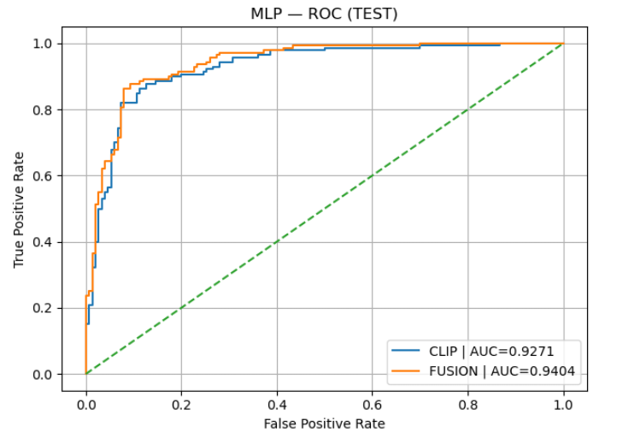

4.3.3. figure 5. MLP-PR
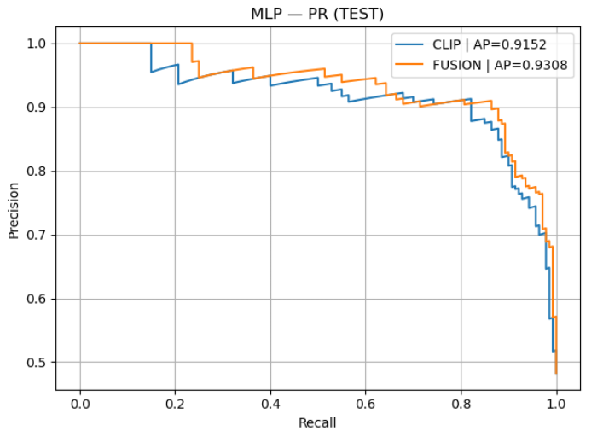
4.3.3. figure 6. HistGradientBoosting - ROC
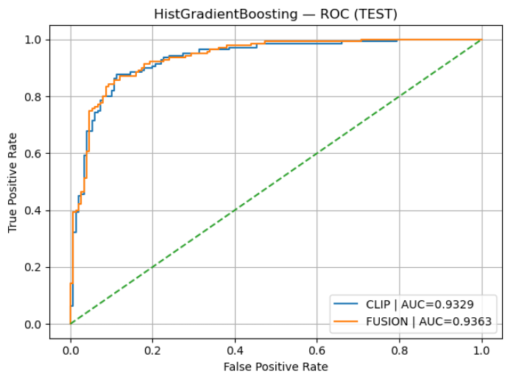
4.3.3. figure 7. HistGradientBoosting - PR
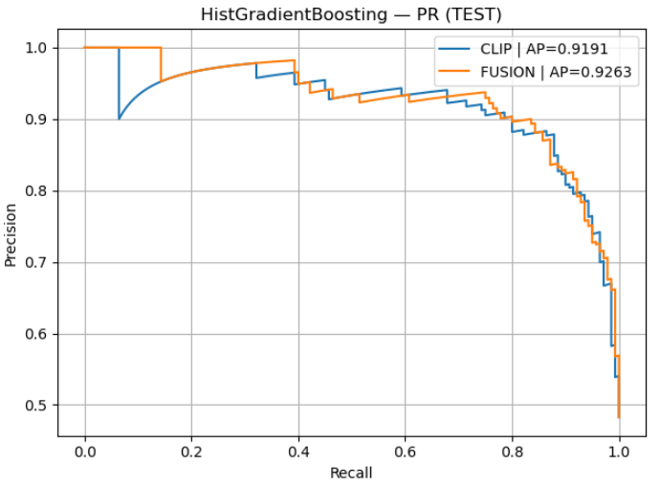
4.3.3. figure 8. Calibrated Linear SVM - ROC
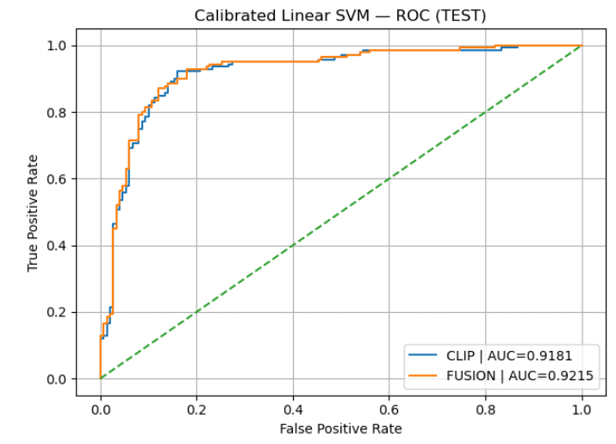
4.3.3. figure 9. Calibrated Linear SVM - PR
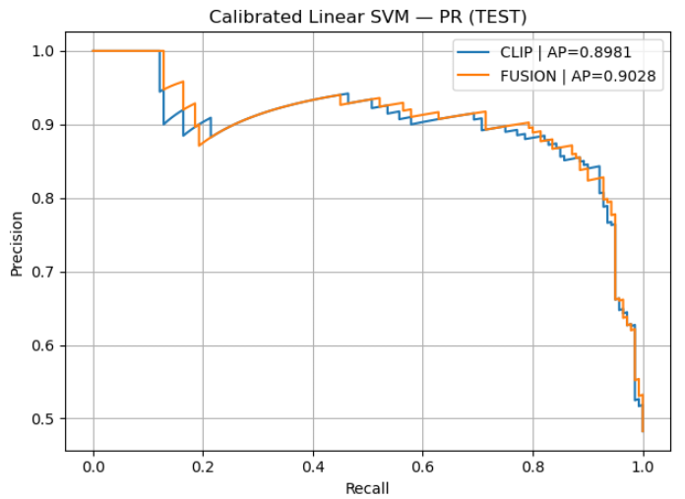

4.4. Metric Explanations
For clarity, we briefly recap the evaluation metrics reported:
- Accuracy: The proportion of correctly classified samples out of all test samples. It provides an overall measure of correctness but may be misleading in imbalanced datasets.
- ROC-AUC (Receiver Operating Characteristic – Area Under Curve): Measures the model’s ability to distinguish between normal and anomalous samples across all classification thresholds. Higher values indicate better separability and robustness to threshold selection.
- PR-AUC (Precision–Recall Area Under Curve): Evaluates the trade-off between precision and recall for the anomaly class. This metric is particularly informative for imbalanced datasets where anomalies are rare.
- Weighted F1-Score: The harmonic mean of precision and recall, averaged across classes and weighted by the number of samples per class. It reflects balanced performance while accounting for class imbalance.

5. Discussion
The experimental results demonstrate that combining semantic representations from a vision-language model (CLIP) with complementary visual analysis from an object detector (YOLOv8) improves the robustness and accuracy of anomaly detection in crowded surveillance scenarios. The CLIP-based model on its own achieved strong performance on the binary anomaly detection task, indicating that high-level visual embeddings extracted by a large-scale pretrained model can effectively capture semantic cues associated with abnormal human behavior, even without explicit textual prompt reasoning. In practical terms, this means CLIP’s understanding of image content (learned from vast image–text data) is sufficiently rich to flag many unusual events: for example, CLIP features might implicitly recognize when a scene contains violence or chaos versus ordinary daily activities.

However, the CLIP-only model also exhibited certain limitations, particularly in cases where anomalous and normal behaviors share similar visual appearances. Such cases highlight the inherent challenge of relying solely on semantic similarity for anomaly detection. If an anomaly is primarily characterized by motion patterns or context (e.g., a person suddenly running in a crowd, which might look similar to someone jogging), a static semantic embedding might not fully distinguish it from normal behavior. We observed that some anomalies missed by the CLIP model were those where the scene’s overall semantic content didn’t drastically change (for instance, a busy crowd scene that remains a “crowd scene” even when an incident is occurring, thus CLIP’s embedding stays similar to a normal crowd). This underscores the need for additional features that can catch subtler cues.

The fusion model, which integrates CLIP-derived semantic features with YOLOv8-based visual features, consistently outperformed the standalone CLIP model across all reported metrics (Accuracy, ROC-AUC, PR-AUC, and F1-score). This improvement suggests that the two modalities provide complementary information: CLIP contributes high-level context and understanding of the scene, while YOLOv8m enhances sensitivity to object-level and spatial cues that are critical in dense crowd environments. For example, YOLO might detect a person carrying an object that is unusual in a given context (like a weapon), or notice an object moving against the flow of the crowd—details that CLIP alone might not flag strongly. By feeding both types of information into the classifier, the fused model can make decisions with a more holistic view of the scene. The increase in ROC-AUC and PR-AUC for the fusion model indicates improved discrimination capability and robustness to class imbalance, which is a common challenge in real-world anomaly detection tasks (where anomalies are rare events). In practice, this means the fused model can more reliably detect anomalies without being overwhelmed by the many normal examples, maintaining high recall of anomalies while controlling false positives better than the single-feature models.

Furthermore, the choice of the classification model was found to have a notable impact on performance. Our comparative experiments with different classifiers (MLP, SVM, logistic regression, random forest, histogram-based gradient boosting) revealed that a more expressive, non-linear model like the MLP or gradient boosting yields higher accuracy and F1-score than simpler models, especially when applied to the fused feature set. In particular, the MLP classifier produced the best results, which suggests that a neural network with sufficient capacity can better exploit the combined semantic and visual feature space. This is intuitively reasonable: the relationship between high-level semantics (from CLIP) and specific visual cues (from YOLO) might be complex, and capturing this synergy may require modeling non-linear interactions. Simpler classifiers (like a linear SVM or logistic regression) assume a mostly linear decision boundary in the feature space, which may underfit the true decision boundary for anomaly detection. The random forest’s underperformance might be due to its inability to effectively handle the high dimensionality of the fused features with the given dataset size, or insufficient tuning. On the other hand, the strong showing of the histogram-based boosting classifier indicates that tree-based methods can also capture complex patterns if properly boosted, though in our case the neural network had a slight edge. These findings guided us to select the MLP as the final classifier in our system. By using a neural model, we ensure the classifier has the flexibility to learn any necessary function of the input features, which proved crucial for maximizing detection performance.

Our results are consistent with observations in prior literature: there is a clear benefit in balancing semantic reasoning and low-level visual precision for video anomaly detection. Vision-language models like CLIP offer broad understanding and can generalize to various contexts because of their training on diverse data, whereas object detection models like YOLOv8m excel at providing real-time, fine-grained information about specific entities and movements in the scene. By combining both approaches in a unified model, our feature-fusion framework mitigates the weaknesses of each individual component. The semantic part covers scenarios that purely visual models might misinterpret (adding contextual awareness), and the visual detection part grounds the analysis in concrete physical events, reducing ambiguity from the semantic embeddings. This synergy is precisely why the fused model not only improves overall accuracy but also specifically reduces the false negative rate – it catches anomalies that were semantically subtle but visually evident (and vice versa).

Despite these promising results, several limitations of our study and method should be acknowledged. First, the current fusion strategy relies on a relatively simple feature concatenation (a late fusion at the feature level). We treat the CLIP and YOLO feature extractors as fixed and independent, and simply join their outputs. It is possible that more advanced fusion mechanisms could further improve performance. For instance, one could use a trainable attention module to weight the contributions of CLIP vs. YOLO features adaptively, or employ a joint encoder that learns an intermediate representation combining both sources of information in a deeper manner. Exploring such feature fusion strategies (e.g., early fusion within a neural network, or using multi-modal transformers) could enhance the model’s ability to detect complex anomalies.

Second, our experiments were limited to binary classification (normal vs. anomaly) using a single dataset. We did not explicitly classify different types of anomalies in this work. Future research should explore multi-class anomaly classification, where the model not only detects an anomaly but also identifies the type of anomaly (e.g., fighting vs. accident vs. burglary). This is a more challenging task but highly relevant for real-world applications, as the response to different anomalies may differ. Additionally, evaluating the model’s generalization across datasets (training on one dataset and testing on another) would be valuable to assess its robustness, since real-world deployment may involve scenes and anomaly patterns that differ from the training data.

We also note that our system currently processes video in short segments with a sliding window; incorporating a more explicit temporal modeling component (such as a recurrent neural network or a temporal attention mechanism that considers sequences of segments) could improve detection of anomalies that unfold over longer durations. Lastly, while the real-time aspect of the system (using YOLOv8 and efficient feature extraction) is promising, the runtime performance should be measured and possibly optimized, especially if scaling to higher-resolution videos or longer continuous monitoring.

6. Conclusions
Overall, the results of this study support the hypothesis that a feature-level fusion approach leveraging both semantic and visual cues is a viable and effective direction for improving anomaly detection in complex, real-world surveillance scenarios. We presented a system that integrates a vision-language model (CLIP) with an object detection model (YOLOv8) by concatenating their feature representations and feeding them into a unified classifier. This approach was shown to outperform models based on either feature source alone, achieving higher accuracy and better recall of anomalies on a challenging crowd anomaly dataset (UCF-Crime). By drawing on CLIP’s high-level understanding of scene context and YOLO’s precise detection of objects and motion, the fused model demonstrated increased robustness in detecting a variety of abnormal behaviors, from subtle to overt, in crowded environments.

Importantly, our investigation into different classifier models underscored the need for flexible, non-linear decision boundaries to fully exploit the fused features; the Multi-Layer Perceptron classifier provided this flexibility and yielded the best results, slightly surpassing a strong gradient boosting method. This indicates that effectively combining multi-source features benefits from classifiers that can capture complex interactions in the data.

In conclusion, this work demonstrates the potential of multimodal feature fusion for enhancing crowd anomaly detection. The proposed approach shows promise for real-world surveillance applications, where reducing missed detections and false alarms can significantly improve safety and security. Future work will aim to extend this framework with more sophisticated fusion techniques and temporal modeling, as well as to tackle fine-grained anomaly classification and cross-domain validation. We believe that integrating semantic vision-language knowledge with traditional visual analytics is a fruitful avenue that can be further built upon to handle the ever-growing demands of intelligent video surveillance.

References
- Dong, M. (2024). CLIP: Assisted Video Anomaly Detection. In Proceedings of the 13th International Conference on Pattern Recognition Applications and Methods (ICPRAM 2024), ScitePress.
- Nasir, R., Jalil, Z., Nasir, M., Alsubait, T., Ashraf, M., & Saleem, S. (2025). An enhanced framework for real-time dense crowd abnormal behavior detection using YOLOv8
- Sultani, W., Chen, C., & Shah, M. (2018). Real-World Anomaly Detection in Surveillance Videos. In Proceedings of the IEEE Conference on Computer Vision and Pattern Recognition (CVPR 2018).
- Garzon, Y., Amir, B., & Natanzon, R. (2025). Seminar Project: Real-Time Crowd Anomaly Detection [Source code]. GitHub. https://github.com/YuvalGarzon/Seminar-Project-Real-time-Crowd-Anomaly

